4. Case Study
Relational Schema: Figure 1 depicts the database schema ISWC_REL.
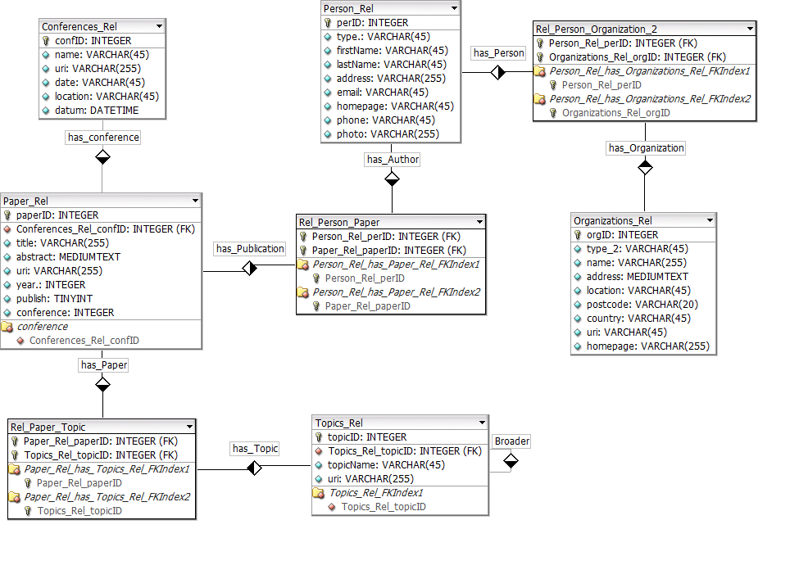
Figure 1. ISWC_REL Database Schema.
Domain Ontology: Figure 2 depicts the domain ontology CONF_OWL, which reuse terms from four well known vocabularies: FOAF (Friend of a Friend), SKOS (Knowledge Organization System) , VCARD and DC (Dublin Core). We use the prefix “conf” for the terms which are defined by the CONF_OWL ontology.

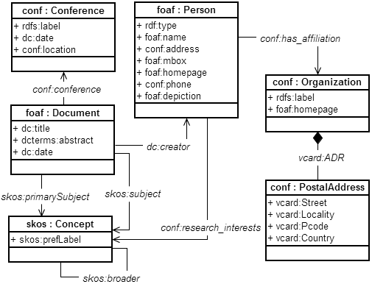
Figure 2. CONF_OWL Domain Ontology.

4.1 Correspondence Assertions
CCAs:
Ψ1: | [foaf:Person] ≡ [Person_Rel[personID]].
: | [foaf:Document] ≡ [Paper_Rel[paperID]].
Ψ3: | [conf:Organization] ≡ [Organization_Rel[orgID]].
Ψ4: | [conf:PostalAddress] ≡ [Organization_Rel[address, location, country]].
Ψ5: | [conf:Conference] ≡ [Conferences_Rel[confID]].
Ψ6: | [skos:Concept] ≡ [Topics_Rel[topicID]].

OCAs
OCA1: | [foaf:Person/conf:has_affiliation] ≡ [Persons_Rel/[ has_Person, has_Organization].
OCA2: | [foaf:Person/conf:has_research_interests] ≡ [Persons_Rel /[ has_Person, has_Publication, has_paper, has_Topic ].
OCA3: | [conf:Organization/vcard:ADR] ≡ [ Organization_Rel / Ψ4].
OCA4: | [foaf:Document/skos:Subject] ≡ [ Papers_Rel /[ hasPaper, hasTopic]].
OCA5: | [foaf:Document/conf:Conference] ≡ [ Papers_Rel /[ hasConference]].
OCA6: | [skos:Concept/skos:broader] ≡ [ Topics_Rel / [ has_broader]].
DCAs
DCA1 | [foaf:Person/foaf:name] ≡ [Persons_Rel /{ firstName, lastName }]
DCA2 | [foaf:Person/conf:address] ≡ [Persons_Rel /address ].
DCA3 | foaf:Person/foaf:mbox] ≡ [Persons_Rel / email ].
DCA4 | foaf:Person/foaf:homepage] ≡ [Persons_Rel / homepage ].
DCA5 | foaf:Person/rdf:type] ≡ [Persons_Rel / type ].
DCA6 | [conf:Organization/rdfs:label] ≡ [ Organization_Rel / name ].
DCA7 | [conf:Organization/foaf:homepage] ≡ [ Organization_Rel / homepage].
DCA8 | [conf:PostalAddress/vcard:Street] ≡ [ Organization_Rel / address].
DCA9 | [conf:PostalAddress/vcard:locality] ≡ [ Organization_Rel / location].
DCA10 | [conf:PostalAddress/vcard:Pcode] ≡ [ Organization_Rel / postcode].
DCA11 | [conf:PostalAddress/vcard:country] ≡ [ Organization_Rel /country].
DCA12 | [conf:PostalAddress/vcard:country] ≡ [ Organization_Rel / country].
DCA13 | [foaf:Document/dc:title] ≡ [ Papers_Rel / title].
DCA14 | [foaf:Document/ dcterms:abstract] ≡ [ Papers_Rel / abstract].
DCA15 | [foaf:Document/dc:date] ≡ [ Papers_Rel / year].
DCA16 | [skos:Concept/skos:prefLabel] ≡ [ Topics_Rel / topicName].
DCA17 | [conf:Conference/rdfs:label] ≡ [ Conferences_Rel / name].
DCA18 | [conf:Conference/dc:date] ≡ [ Conferences_Rel / date].
DCA19 | [conf:Conference/conf:location] ≡ [ Conferences_Rel / location].

http://www.foaf-project.org/
http://www.w3.org/TR/skos-reference/
http://www.w3.org/TR/vcard-rdf/
http://dublincore.org/

